Gradients of Line Segments
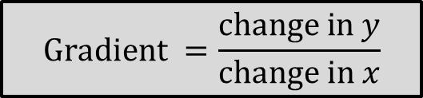
Look for points where each line passes through corners on the grid. Use those points to draw a gradient triangle. Work out the gradient of each line.

Food for thought…
What is the gradient of a horizontal line? What is the gradient of a vertical line?

Gradients of Line Segments
Look for points where each line passes through corners on the grid. Use those points to draw a gradient triangle. Work out the gradient of each line.

Food for thought…
What is the gradient of a horizontal line? What is the gradient of a vertical line?

