**Vectors Exam Questions**

1.



is a triangle.   
 is the point on for which

and .

(a) Write down, in terms of and , an expression for

……………………

(1)

(b) Express in terms of and .  
Give your answer in its simplest form.

……………………

(2)

(Total 3 marks)

2. is a straight line.



is a point so that and

is the midpoint of .  
 is the midpoint of .

Express, in terms of and , the vectors

(i)

.....................................

(ii)

.....................................

(Total 3 marks)

3. Diagram NOT accurately drawn



is a parallelogram. is parallel to *.* is parallel to *.*

(a) Express, in terms of and

(i)

.....................................

(ii)

.....................................

(2)



and are diagonals of parallelogram *.* and intersect at *.*

(b) Express in terms of and .

.....................................

(1)

(Total 3 marks)

4.



is a parallelogram.

is the point on such that

(a) Find the vector   
Give your answer in terms of and

..............................

(3)

The midpoint of is .

(b) Prove that is a straight line.

(2)

(Total 5 marks)

5.



is a triangle.  
 is the midpoint of .  
 is the midpoint of .  
 and

(i) Find in terms of and .

..........................

(ii) Show that is parallel to .

(Total 5 marks)

6.

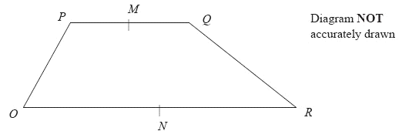

is a trapezium with parallel to .

is the midpoint of and is the midpoint of .

(a) Find the vector in terms of and .

...................................

(2)

is the midpoint of and is the midpoint of *.*

(b) Prove that is parallel to *.*

(2)

(Total 4 marks)

7.



Diagram NOT accurately drawn

is a triangle. is the midpoint of .  
 is the midpoint of .

(a) Find, in terms of and , the vectors

(i)

..........................................

(ii)

..........................................

(iii)

..........................................

(4)

(b) Hence explain why is a straight line.

(2)

The length of is 3 cm.

(c) Find the length of .

.................................... cm

(1)

(Total 7 marks)

8.



The diagram shows a regular hexagon with centre .

(a) Express in terms of and/or

(i)

.....................................

(ii)

.....................................

(2)

is the midpoint of .

(b) Express in terms of and/or

.....................................

(2)

is the point on extended, such that

(c) Prove that , and lie on the same straight line.

(3)

(Total 7 marks)