**Volume and Surface Area (F)**

Post-Intervention Assessment

Name: _______________________________

Class: _______________________________

Date: _______________________________

|  |  |  |
| --- | --- | --- |
| **Question** | **Objective** | **RAG** |
| 1 | Calculate volume and surface area of cubes and cuboids |  |
| 2 | Calculate volume and surface area of prisms, including cylinders |  |

**1.** The diagram shows a sand pit. The sand pit is in the shape of a cuboid.

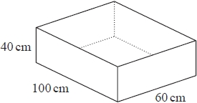

Sally wants to fill the sand pit with sand.   
A bag of sand costs £2.50   
There are 8 litres of sand in each bag.

Sally says, "The sand will cost less than £70"

Show that Sally is wrong.

**2**. The diagram shows a prism.

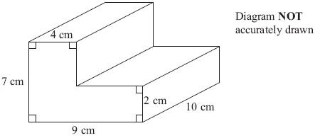

Work out the volume of the prism.

[Glue here]