**Angles around a point, on a line and in triangle EXTENSION**

**1.** Diagram **NOT** accurately drawn



*ABC* is a straight line.

Work out the size of angle *x.*Give a reason for your answer.

.....................................°

...............................................................................................................................

(Total 3 marks)

**2.** (a)



Diagram **NOT** accurately drawn

*LMN* is a straight line.

(i) Work out the value of *x*.

*x* = ....................................

(ii) Give a reason for your answer.

...............................................................................................................................

...............................................................................................................................

(2)

(b)



Diagram **NOT** accurately drawn

Work out the value of *y*.

*y* = ....................................

(2)

(Total 4 marks)

**3.**



Diagram **NOT** accurately drawn

This diagram is **wrong**.

Explain why.

...............................................................................................................................

...............................................................................................................................

(Total 1 mark)

**4.**



(a) (i) Find the size of angle C.

..........................°

(ii) Triangle *ABC* is equilateral.  
Explain why.

.....................................................................................................................

(2)

(b)

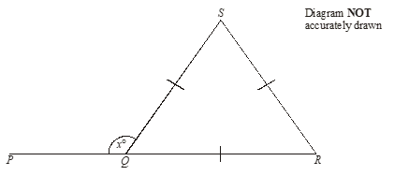

*PQR* is a straight line.  
*SQ* *=* *SR = RQ.*

(i) Work out the size of the angle marked *x*°.

..........................°

(ii) Give reasons for your answer.

.....................................................................................................................

.....................................................................................................................

(3)

(Total 5 marks)

**5.**



Diagram **NOT** accurately drawn

*ABC* is an isosceles triangle.

The angle marked *x* is 50º  
Give reasons why.

.....................................................................................................................................

(Total 2 marks)

**6.**



Diagram **NOT** accurately drawn

(a) Work out the value of *x*.

*x* = ………….

(1)

(b) Work out the value of *y*.

*y* = ………….

(2)

(Total 3 marks)