**Scale Drawings EXTENSION**

Below are pictures of some of the largest buildings in the world. The Nanjing Complex is 450m high. Based on this, calculate the scale being used on the grid and subsequently the height of each building. Write the heights at the bottom of the sheet and fill in the scale up the side.

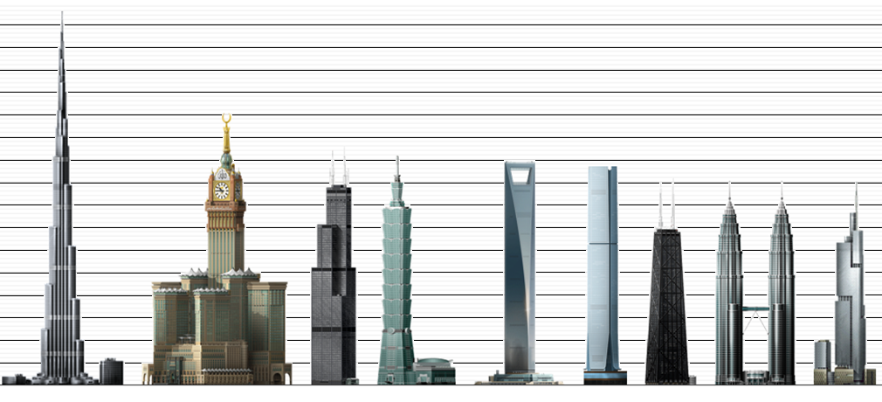

Nanjing Financial Complex - Nanjing

International Commerce Centre – Hong Kong

Burj Khalifa - Dubai

Makkah Royal Clock Tower Hotel - Mecca

The Willis ‘Sears’ Tower - Chicago

Taipei 101 - Taipei

Shanghai World Financial Centre - Shanghai

John Hancock Centre - Chicago

Petronas Towers – Kuala Lumpur

Estimated Height

Estimated Height

Estimated Height

Estimated Height

Estimated Height

Estimated Height

Estimated Height

Estimated Height

Estimated Height

On this grid you are given the height of ‘The Index’, a building in Dubai, as being 330m. Draw the other buildings on the diagram, based on their heights and the photographs you can see. Extension: You are to design a high-rise block in London which must be 650m tall and no more than 100m wide at the base. Draw your building on the diagram as well!

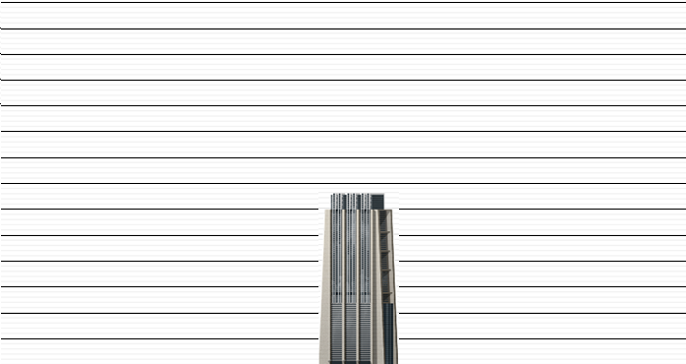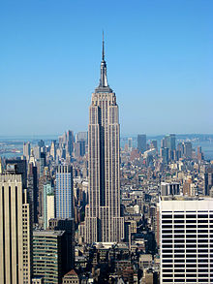

Empire State Building – New York

Height: 443m

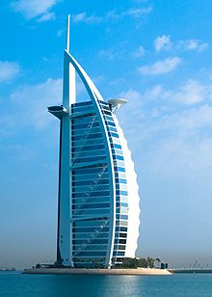

Burj Al-arab - Dubai

Height: 321m

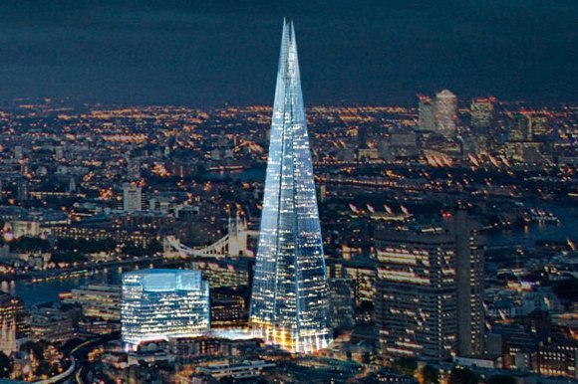

The Index - Dubai

Height: 330m

The Shard - London

Height: 310m