**Set Theory Starter**

Sort the numbers 1 – 10 into this Venn diagram.

**Then write down the numbers in A U B’.**

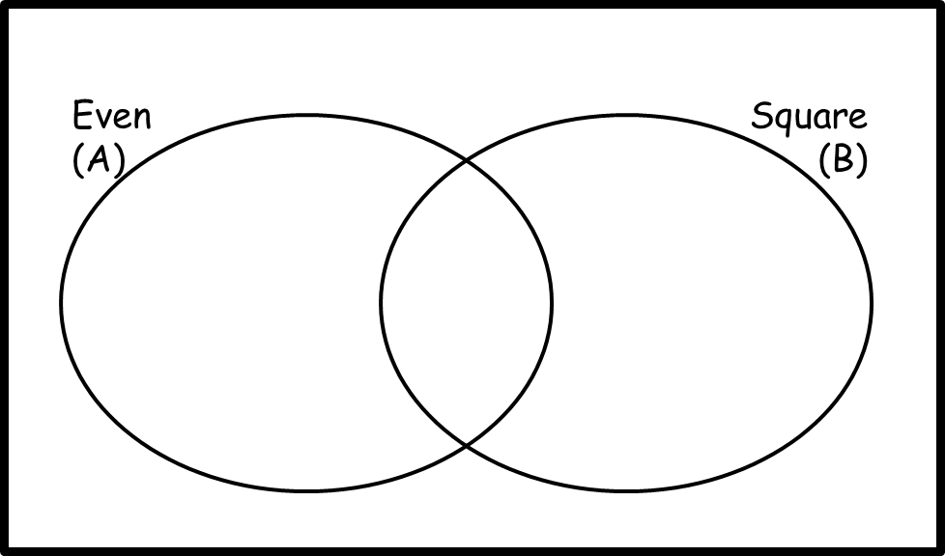

**Set Theory Starter**

Sort the numbers 1 – 10 into this Venn diagram.

**Then write down the numbers in A U B’.**



**Set Theory Starter**

Sort the numbers 1 – 10 into this Venn diagram.

**Then write down the numbers in A U B’.**



**Set Theory Starter**

Sort the numbers 1 – 10 into this Venn diagram.

**Then write down the numbers in A U B’.**

