Conversion Graphs GREEN

1) You can use the information in the table to convert between kilometres and miles.
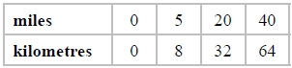

a) Use this information to draw a conversion graph.
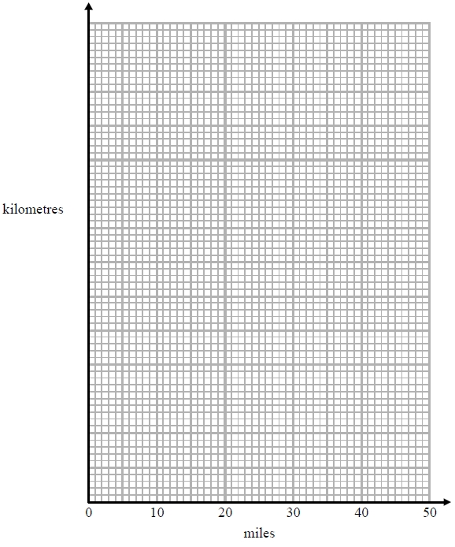
b) Which is further, 20 kilometres or 15 miles?
You must show how you got your answer.

2) The table shows some weights in grams and the same weights in ounces.

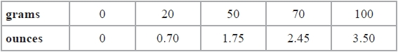

a) On the grid, use this information to draw a line you can use to change between grams and ounces.
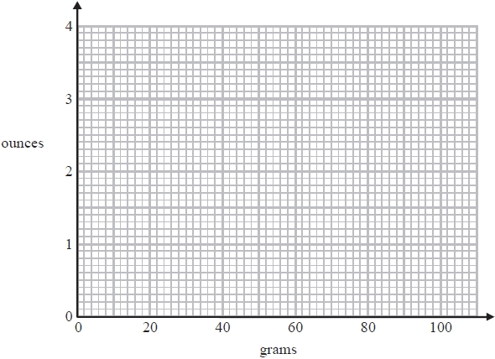
There are 24 eggs in a tray of eggs.
Each egg has a weight of 64 grams.
The tray has a weight of 1.6 ounces.
b) Work out the total weight of the 24 eggs and the tray.

3) These graphs can be used to convert between pounds (£), Euros (€) and US dollars ($).
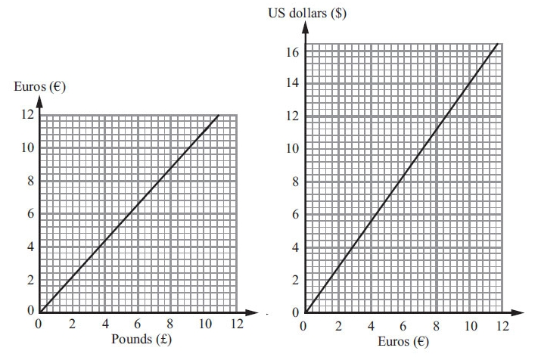
- Convert £6 to Euros (€).

- Convert $5 to Euros (€).

On the internet, Amir sees a pair of trainers.
The trainers cost $65
- Work out the cost of the trainers in pounds (£).

4) Barbara goes on holiday to Prague. The currency in Prague is the Koruna (KC).
This graph can be used to convert between £ (pounds) and KC (Koruna).
The exchange rate is £1 = 30 KC.

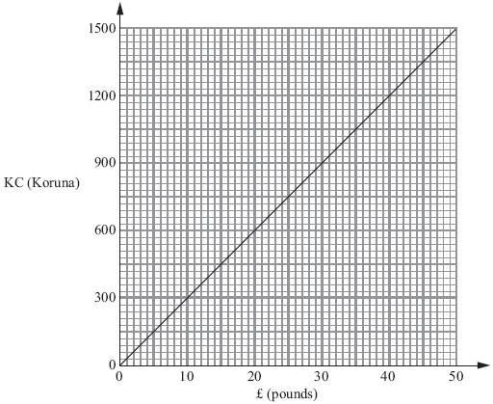

Barbara bought some things in London. She saw the same things on sale in Prague.
The table shows the cost in £ (pounds) and the cost in KC (Koruna).

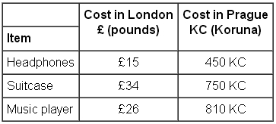

Barbara thinks the total cost of these things was more in London than in Prague.
Is she correct? Give a reason for your answer. You must show all your working.

Conversion Graphs AMBER

1) You can use the information in the table to convert between kilometres and miles.
Plot these coordinates on the graph below. Make sure you are plotting the values against the correct axis. Label the vertical axis first!

a) Use this information to draw a conversion graph.
b) Which is further, 20 kilometres or 15 miles?
You must show how you got your answer.

2) The table shows some weights in grams and the same weights in ounces.

a) On the grid, use this information to draw a line you can use to change between grams and ounces.
There are 24 eggs in a tray of eggs.
Convert both given weights to the same unit. Remember there are 24 eggs!
Each egg has a weight of 64 grams.
The tray has a weight of 1.6 ounces.
b) Work out the total weight of the 24 eggs and the tray.

3) These graphs can be used to convert between pounds (£), Euros (€) and US dollars ($).
- Convert £6 to Euros (€).

- Convert $5 to Euros (€).

On the internet, Amir sees a pair of trainers.
The trainers cost $65
Convert the price to Euros first, then use the other graph to convert to GBP.
- Work out the cost of the trainers in pounds (£).

4) Barbara goes on holiday to Prague. The currency in Prague is the Koruna (KC).
This graph can be used to convert between £ (pounds) and KC (Koruna).
The exchange rate is £1 = 30 KC.

Barbara bought some things in London. She saw the same things on sale in Prague.
The table shows the cost in £ (pounds) and the cost in KC (Koruna).

Work out the total in both places, then convert to the same currency and compare.

Barbara thinks the total cost of these things was more in London than in Prague.
Is she correct? Give a reason for your answer. You must show all your working.

Conversion Graphs RED

1) You can use the information in the table to convert between kilometres and miles.
Plot these coordinates on the graph below. Make sure you are plotting the values against the correct axis. Label the vertical axis first!

a) Use this information to draw a conversion graph.
b) Which is further, 20 kilometres or 15 miles?
You must show how you got your answer.
Is this more or less than 20 km?
15 miles = ________ km

2) The table shows some weights in grams and the same weights in ounces.

a) On the grid, use this information to draw a line you can use to change between grams and ounces.
There are 24 eggs in a tray of eggs.
Convert both given weights to the same unit. Remember there are 24 eggs!
Each egg has a weight of 64 grams.
The tray has a weight of 1.6 ounces.
b) Work out the total weight of the 24 eggs and the tray.
1.6 oz = ________ g

(24 x 64) + ________ = ________ g

3) These graphs can be used to convert between pounds (£), Euros (€) and US dollars ($).
- Convert £6 to Euros (€).

- Convert $5 to Euros (€).

On the internet, Amir sees a pair of trainers.
The trainers cost $65
Convert the price to Euros first, then use the other graph to convert to GBP.
- Work out the cost of the trainers in pounds (£).

$65 = €________ = £________

4) Barbara goes on holiday to Prague. The currency in Prague is the Koruna (KC).
This graph can be used to convert between £ (pounds) and KC (Koruna).
The exchange rate is £1 = 30 KC.

Barbara bought some things in London. She saw the same things on sale in Prague.
The table shows the cost in £ (pounds) and the cost in KC (Koruna).

Work out the total in both places, then convert to the same currency and compare.

Barbara thinks the total cost of these things was more in London than in Prague.
Is she correct? Give a reason for your answer. You must show all your working.

Total cost in London = £________

Total cost in Prague = ________ KC = £________

