Pictograms GREEN
1) The pictogram shows information about the number of books sold in a
shop on Monday, on Tuesday and on Wednesday one week.
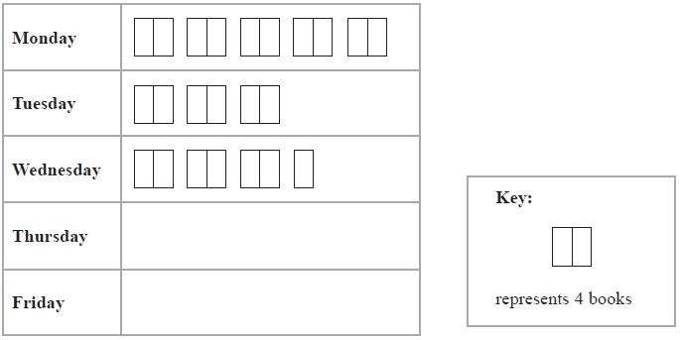
(a) Write down the number of books sold on Monday.

...........................................................
(1)
(b) Write down the number of books sold on Wednesday.

...........................................................
(1)
8 books were sold on Thursday.
18 books were sold on Friday.

(c) Use this information to complete the pictogram.
(2)
(Total for question = 4 marks)

2) The pictogram shows the numbers of parcels delivered to some houses on Monday, Tuesday and Wednesday.

Monday
Tuesday
Wednesday | Key:  = 4 parcels
Thursday
Friday

(a) Write down the number of parcels delivered on Tuesday.

...........................................................
(1)
(b) Write down the number of parcels delivered on Wednesday.

...........................................................
(1)
24 parcels were delivered on Thursday.
18 parcels were delivered on Friday.
(c) Use this information to complete the pictogram.
(2)
(Total for Question is 4 marks)

3) The pictogram shows the number of cakes sold in a shop on Monday, on Tuesday, on Wednesday and on Thursday one week.
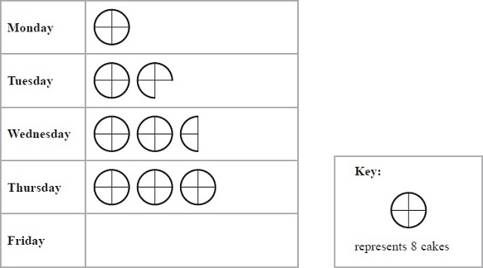
(a) How many cakes were sold on Thursday?

...........................................................
(1)
(b) Work out the total number of cakes sold on Monday and Tuesday.

...........................................................
(1)
On Friday this week 12 cakes were sold in the shop.
(c) Show this information on the pictogram.
(1)
(Total for Question is 4 marks)

4) Here is a pictogram. It shows the number of goals scored by Ali, by Ben and by Charlie.

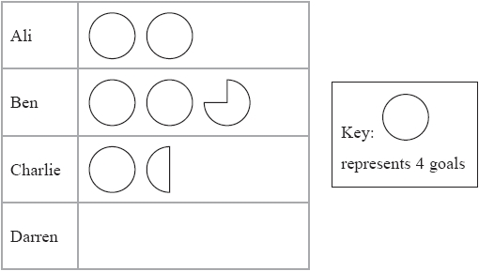

(a) Who scored the least number of goals, Ali or Ben or Charlie?

...........................................................
(1)
(b) Write down the number of goals scored by Ali.

...........................................................
(1)
(c) Write down the number of goals scored by Ben.

...........................................................
(1)
Darren scored 10 goals.

(d) Show this information on the pictogram.
(1)
(Total for question = 4 marks)

Pictograms AMBER
1) The pictogram shows information about the number of books sold in a
shop on Monday, on Tuesday and on Wednesday one week.
(a) Write down the number of books sold on Monday.
(Don’t forget to use the key!)

...........................................................
(1)
(b) Write down the number of books sold on Wednesday.

...........................................................
(1)
8 books were sold on Thursday.
18 books were sold on Friday.

(c) Use this information to complete the pictogram.
(2)
(Total for question = 4 marks)

2) The pictogram shows the numbers of parcels delivered to some houses on Monday, Tuesday and Wednesday.

Monday
Tuesday
Wednesday | Key:  = 4 parcels
Thursday
Friday

(a) Write down the number of parcels delivered on Tuesday.
(Don’t forget to use the key!)

...........................................................
(1)
(b) Write down the number of parcels delivered on Wednesday.

...........................................................
(1)
24 parcels were delivered on Thursday.
18 parcels were delivered on Friday.
(c) Use this information to complete the pictogram.
(2)
(Total for Question is 4 marks)

3) The pictogram shows the number of cakes sold in a shop on Monday, on Tuesday, on Wednesday and on Thursday one week.
(a) How many cakes were sold on Thursday?
(Don’t forget to use the key!)

...........................................................
(1)
(b) Work out the total number of cakes sold on Monday and Tuesday.
(Add together the values for Monday and Tuesday)

...........................................................
(1)
On Friday this week 12 cakes were sold in the shop.
(c) Show this information on the pictogram.
(1)
(Total for Question is 4 marks)

4) Here is a pictogram. It shows the number of goals scored by Ali, by Ben and by Charlie.

(a) Who scored the least number of goals, Ali or Ben or Charlie?
(Which line has the fewest symbols?)

...........................................................
(1)
(b) Write down the number of goals scored by Ali.

...........................................................
(1)
(c) Write down the number of goals scored by Ben.

...........................................................
(1)
Darren scored 10 goals.

(d) Show this information on the pictogram.
(1)
(Total for question = 4 marks)

Pictograms RED
1) The pictogram shows information about the number of books sold in a
shop on Monday, on Tuesday and on Wednesday one week.
(a) Write down the number of books sold on Monday.
(Don’t forget to use the key – count up in 4s to begin with)

...........................................................
(1)
(b) Write down the number of books sold on Wednesday.

...........................................................
(1)
8 books were sold on Thursday.
18 books were sold on Friday.

(c) Use this information to complete the pictogram.
(How many whole symbols do you need, and how many halves?)
(2)
(Total for question = 4 marks)

2) The pictogram shows the numbers of parcels delivered to some houses on Monday, Tuesday and Wednesday.

Monday
Tuesday
Wednesday | Key:  = 4 parcels
Thursday
Friday

(a) Write down the number of parcels delivered on Tuesday.
(Don’t forget to use the key – count up in 4s to begin with)

...........................................................
(1)
(b) Write down the number of parcels delivered on Wednesday.

...........................................................
(1)
24 parcels were delivered on Thursday.
18 parcels were delivered on Friday.
(c) Use this information to complete the pictogram.
(How many whole symbols do you need, and how many halves? What about quarters?)
(2)
(Total for Question is 4 marks)

3) The pictogram shows the number of cakes sold in a shop on Monday, on Tuesday, on Wednesday and on Thursday one week.
(a) How many cakes were sold on Thursday?
(Don’t forget to use the key – count up in 8s to begin with)

...........................................................
(1)
(b) Work out the total number of cakes sold on Monday and Tuesday.
(Add together the values for Monday and Tuesday)

...........................................................
(1)
On Friday this week 12 cakes were sold in the shop.
(c) Show this information on the pictogram.
(1)
(Total for Question is 4 marks)

4) Here is a pictogram. It shows the number of goals scored by Ali, by Ben and by Charlie.

(a) Who scored the least number of goals, Ali or Ben or Charlie?
(Which line has the fewest symbols?)

...........................................................
(1)
(b) Write down the number of goals scored by Ali.

...........................................................
(1)
(c) Write down the number of goals scored by Ben.

...........................................................
(1)
Darren scored 10 goals.

(d) Show this information on the pictogram.
(1)
(Total for question = 4 marks)

