Speed from Distance-Time Graphs - Green

A small bus set off from Leeds to pick up Mike and his family. It then went on to pick up Mike’s parents and grandparents. It then travelled further, dropping them all off at a hotel. The bus then went on a further 10km to pick up another party and it took them back to Leeds. This distance-time graph illustrates the journey.

a) How far from Leeds did Mike’s parents and grandparents live? _______ km
b) How far from Leeds is the hotel at which they all stayed? _______ km
c) What was the average speed of the bus to Mike’s house? _______ km/h
d) What was the average speed of the bus from Mike’s house to his parents? _______ km/h
e) What was the average speed of the bus on its way back to Leeds? _______ km/h

Speed from Distance-Time Graphs - Green

A small bus set off from Leeds to pick up Mike and his family. It then went on to pick up Mike’s parents and grandparents. It then travelled further, dropping them all off at a hotel. The bus then went on a further 10km to pick up another party and it took them back to Leeds. This distance-time graph illustrates the journey.

a) How far from Leeds did Mike’s parents and grandparents live? _______ km
b) How far from Leeds is the hotel at which they all stayed? _______ km
c) What was the average speed of the bus to Mike’s house? _______ km/h
d) What was the average speed of the bus from Mike’s house to his parents? _______ km/h
e) What was the average speed of the bus on its way back to Leeds? _______ km/h
Speed from Distance-Time Graphs - Amber

A small bus set off from Leeds (A) to pick up Mike and his family (B). It then went on to pick up Mike’s parents and grandparents (C). It then travelled further, dropping them all off at a hotel (D). The bus then went on a further 10km to pick up another party (E) and it took them back to Leeds (F). This distance-time graph illustrates the journey.

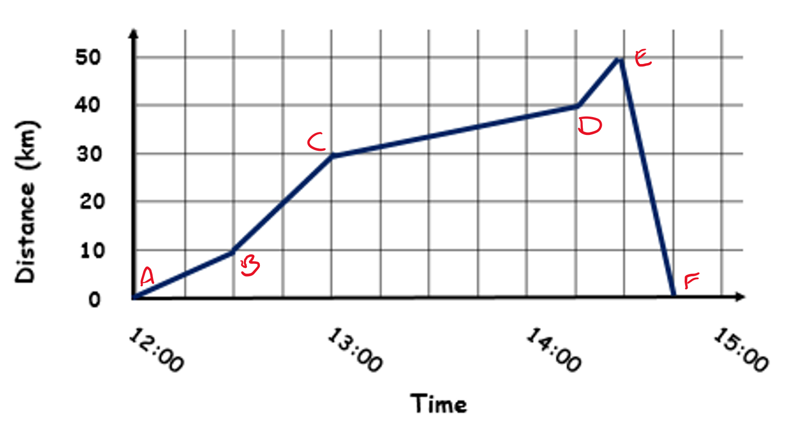

a) How far from Leeds did Mike’s parents and grandparents live? _______ km
b) How far from Leeds is the hotel at which they all stayed? _______ km
c) What was the average speed of the bus to Mike’s house? _______ km/h
$10 km ÷ \frac{1}{2} hour=$
d) What was the average speed of the bus from Mike’s house to his parents? _______ km/h
e) What was the average speed of the bus on its way back to Leeds? _______ km/h

Speed from Distance-Time Graphs - Amber

A small bus set off from Leeds (A) to pick up Mike and his family (B). It then went on to pick up Mike’s parents and grandparents (C). It then travelled further, dropping them all off at a hotel (D). The bus then went on a further 10km to pick up another party (E) and it took them back to Leeds (F). This distance-time graph illustrates the journey.

a) How far from Leeds did Mike’s parents and grandparents live? _______ km
b) How far from Leeds is the hotel at which they all stayed? _______ km
c) What was the average speed of the bus to Mike’s house? _______ km/h
$10 km ÷ \frac{1}{2} hour=$
d) What was the average speed of the bus from Mike’s house to his parents? _______ km/h
e) What was the average speed of the bus on its way back to Leeds? _______ km/h
Speed from Distance-Time Graphs - Red

A small bus set off from Leeds (A) to pick up Mike and his family (B). It then went on to pick up Mike’s parents and grandparents (C). It then travelled further, dropping them all off at a hotel (D). The bus then went on a further 10km to pick up another party (E) and it took them back to Leeds (F). This distance-time graph illustrates the journey.
a) How far from Leeds did Mike’s parents and grandparents live? _______ km
b) How far from Leeds is the hotel at which they all stayed? _______ km
c) What was the average speed of the bus to Mike’s house? _______ km/h
$10 km ÷ \frac{1}{2} hour=$
d) What was the average speed of the bus from Mike’s house to his parents? _______ km/h
$20 km ÷ \frac{1}{2} hour=$
e) What was the average speed of the bus on its way back to Leeds? _______ km/h

Speed from Distance-Time Graphs - Red

A small bus set off from Leeds (A) to pick up Mike and his family (B). It then went on to pick up Mike’s parents and grandparents (C). It then travelled further, dropping them all off at a hotel (D). The bus then went on a further 10km to pick up another party (E) and it took them back to Leeds (F). This distance-time graph illustrates the journey.
a) How far from Leeds did Mike’s parents and grandparents live? _______ km
b) How far from Leeds is the hotel at which they all stayed? _______ km
c) What was the average speed of the bus to Mike’s house? _______ km/h
$10 km ÷ \frac{1}{2} hour=$
d) What was the average speed of the bus from Mike’s house to his parents? _______ km/h
$20 km ÷ \frac{1}{2} hour=$
e) What was the average speed of the bus on its way back to Leeds? _______ km/h

