Drawing and Measuring Lines and Angles EXTENSION

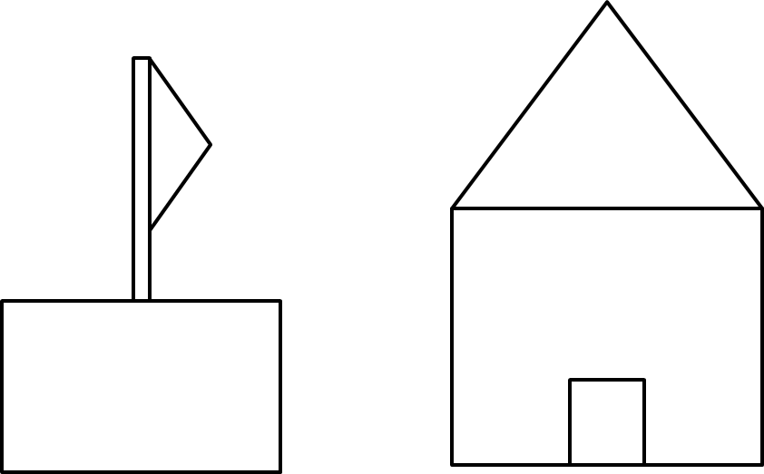

Drawing and Measuring Lines and Angles EXTENSION

