Area and Volume Unit Conversions GREEN

1) 84 mm2 into cm2

2) 1750 cm2 into m2

3) 29 000 mm2 into cm2

4) 3 150 000 m2 into km2

5) 8500 mm2 into cm2

6) 1700 cm2 into m2

7) 0.001 km3 into m3

8) 15 cm3 into mm3

9) 0.2 m3 into cm3

10) 0.435 km3 into m3

11) 1.2 m2 into mm2

12) 0.001 km2 into cm2

13) 50 million mm2 into m2

14) 673 000 000 cm2 into km2

15) 0.000005 km2 into mm2

16) 60 500 mm2 into m2

17) 3 million mm3 into km3

18) 0.0006 m3 into mm3

19) 999 cm3 into km3

20) 17 440 mm3 into m3

21) Sandeesh wants to carpet 2 rectangular rooms.

One of the room measures 1.7m by 3m, while the other is 670cm by 420cm.

How many square metres of carpet will she need?

22) A swimming pool measures 3m deep and has a base with area 375m2

a) Find the volume of the pool in cm3.

b) How many litres of water can the pool hold?

Area and Volume Unit Conversions AMBER

Complete the diagrams below to help you write conversions for the questions:

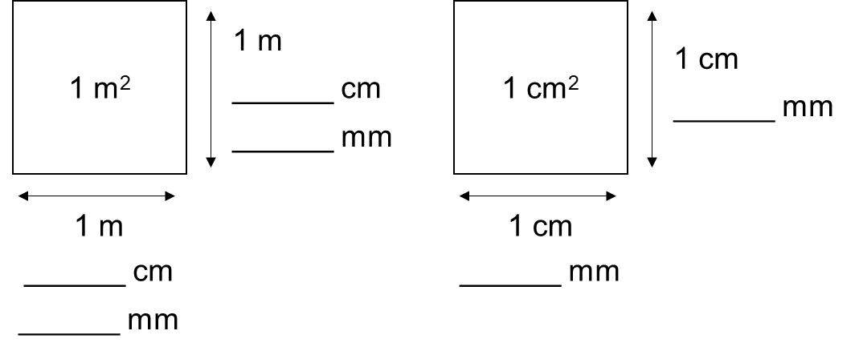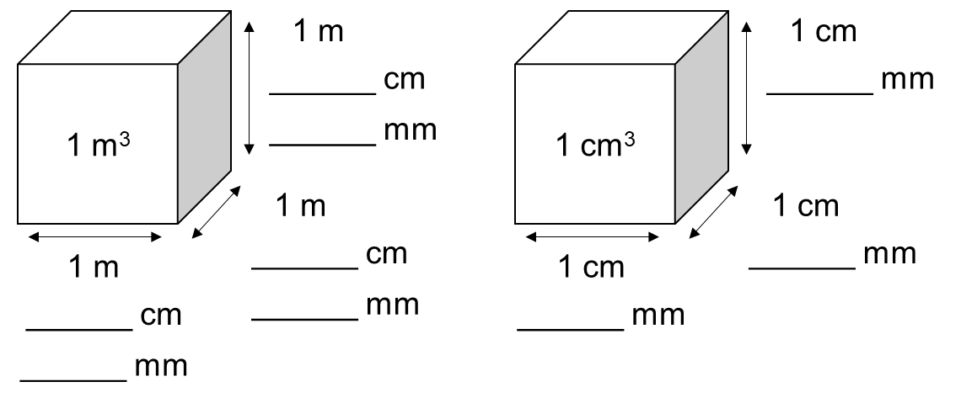

1) 84 mm2 into cm2

2) 1750 cm2 into m2

3) 29 000 mm2 into cm2

4) 3 150 000 m2 into km2

5) 8500 mm2 into cm2

6) 1700 cm2 into m2

7) 0.001 km3 into m3

8) 15 cm3 into mm3

9) 0.2 m3 into cm3

10) 0.435 km3 into m3

11) 1.2 m2 into mm2

12) 0.001 km2 into cm2

13) 50 million mm2 into m2

14) 673 000 000 cm2 into km2

15) 0.000005 km2 into mm2

16) 60 500 mm2 into m2

17) 3 million mm3 into km3

18) 0.0006 m3 into mm3

19) 999 cm3 into km3

20) 17 440 mm3 into m3

Area and Volume Unit Conversions RED

Complete the diagrams below to help you write conversions for the questions:

1 m2 = _______________ cm2 1 m3 = _______________ cm3

1 m2 = _______________ mm2 1 m3 = _______________ mm3

1 cm2 = _______________ mm2 1 cm3 = _______________ mm3

1) 84 mm2 into cm2

2) 1750 cm2 into m2

3) 29 000 mm2 into cm2

4) 3 150 000 m2 into km2

5) 8500 mm2 into cm2

6) 1700 cm2 into m2

7) 0.001 km3 into m3

8) 15 cm3 into mm3

9) 0.2 m3 into cm3

10) 0.435 km3 into m3

11) 1.2 m2 into mm2

12) 0.001 km2 into cm2

13) 50 million mm2 into m2

14) 673 000 000 cm2 into km2

15) 0.000005 km2 into mm2

16) 60 500 mm2 into m2

17) 3 million mm3 into km3

18) 0.0006 m3 into mm3

19) 999 cm3 into km3

20) 17 440 mm3 into m3