Graphical Proportionality GREEN

**Question 1**

a) is directly proportional to . On the b) is inversely proportional to . On the

axes, sketch the graph of against . axes, sketch the graph of against .

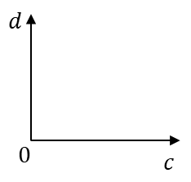 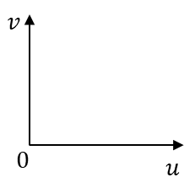

**Question 2**

a) is directly proportional to . b) is inversely proportional to .

i) Draw a graph in your book by i) Draw a graph in your book by

completing the table of values. completing the table of values.

ii) Use the graph to estimate the value ii) Use the graph to estimate the value

of when . of when .

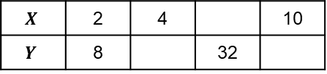 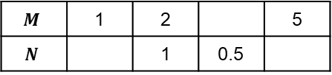

**Question 3**

Four of the graphs of against represent four different types of proportionality. Match each type of proportionality in the table to the correct graph. Beware the red herrings!

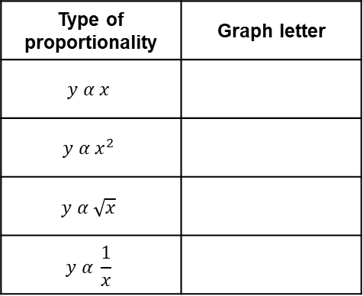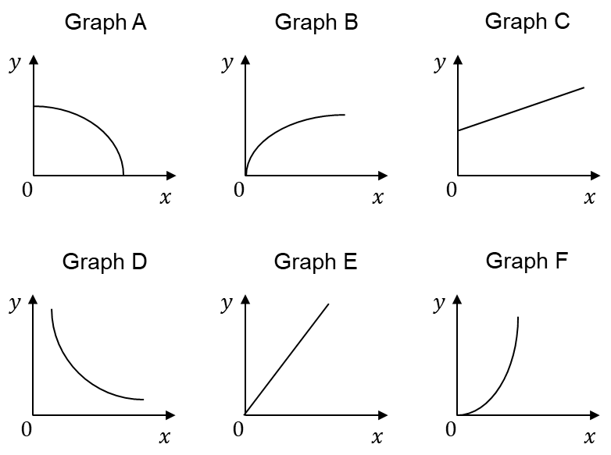

Graphical Proportionality AMBER

**Question 1**

a) is directly proportional to . On the b) is inversely proportional to . On the

axes, sketch the graph of against . axes, sketch the graph of against .

 

**Question 2**

a) is directly proportional to . b) is inversely proportional to .

i) Draw a graph in your book by i) Draw a graph in your book by

completing the table of values. completing the table of values.

ii) Use the graph to estimate the value ii) Use the graph to estimate the value

of when . of when .

 

(Substitute and (Substitute and

from the table) from the table)

**Question 3**

Four of the graphs of against represent four different types of proportionality. Match each type of proportionality in the table to the correct graph. Beware the red herrings!



Start by eliminating any graphs you know cannot represent proportion.

Graphical Proportionality RED

**Question 1**

a) is directly proportional to . On the b) is inversely proportional to . On the

axes, sketch the graph of against . axes, sketch the graph of against .

 

**Question 2**

a) is directly proportional to . b) is inversely proportional to .

i) Draw a graph in your book by i) Draw a graph in your book by

completing the table of values. completing the table of values.

ii) Use the graph to estimate the value ii) Use the graph to estimate the value

of when . of when .

 

(Substitute and (Substitute and

from the table) from the table)

(Use this proportion (Use this proportion

equation to fill in the equation to fill in the

rest of the table) rest of the table)

**Question 3**

Four of the graphs of against represent four different types of proportionality. Match each type of proportionality in the table to the correct graph. Beware the red herrings!



Start by eliminating any graphs you know cannot represent proportion. Look back at notes you have made to help you match up the graphs with the type of proportion they represent.