**Volume and Surface Area (H)**

Intervention Booklet

Name: _______________________________

Class: _______________________________

**Useful websites:**

**www.mathswatchvle.com**

*(Video explanations and questions)*

Username: STH…@twgash

Password: stmaths

**www.methodmaths.com**

*(Past papers online that get instantly marked)*

Centre ID: wga

Username: firstname

Password: lastname

**www.hegartymaths.com**

*(Online tutorials and quizzes)*

Login: first name and last name are case sensitive

**www.bbc.co.uk/schools/gcsebitesize/maths**

**Prisms (Including Cylinders)**

**Things to remember:**

* Volume of a prism = area of cross section x vertical height
* Area of triangle = b x h
* Area of circle = π r²
* To calculate the surface area, work out the area of the surface!

**Questions:**

**1.** Work out the volume of the triangular prism.

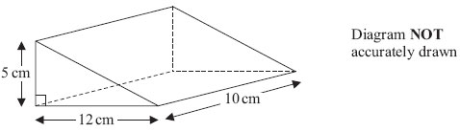

...........................................................cm3

**(Total for Question is 2 marks)**

**2.** Here is a triangular prism.

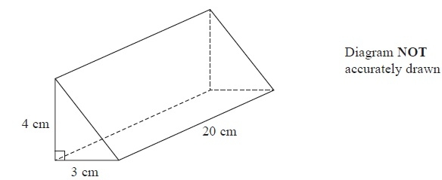

Work out the volume of this triangular prism.

...........................................................

**(Total for Question is 4 marks)**

**3.** The diagram shows a prism.

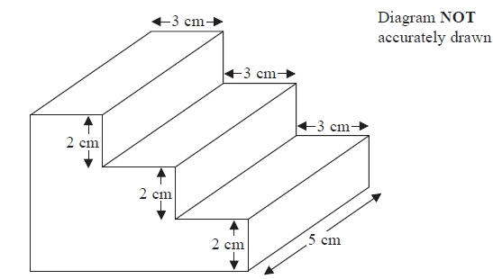

All the corners are right angles.

Work out the volume of the prism.

...........................................................cm3

**(Total for question = 3 marks)**

**4**. Here is a prism.

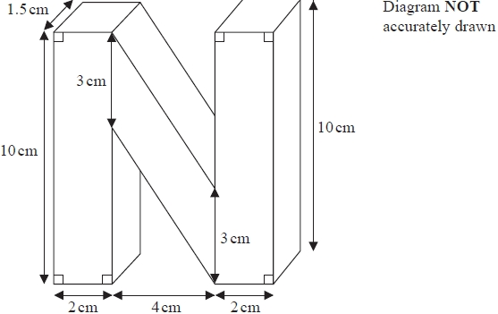

Work out the volume of the prism.

...........................................................cm3

**(Total for question = 4 marks)**

**5.** Here is a solid prism.

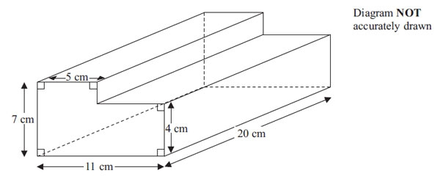

Work out the volume of the prism.

...........................................................cm3

**(Total for Question is 3 marks)**

**6**. The diagram shows a triangular prism.

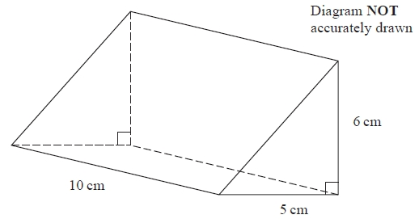

Work out the volume of the prism.

...........................................................

**(Total for question = 3 marks)**

**7**. The diagram shows a large tin of pet food in the shape of a cylinder.

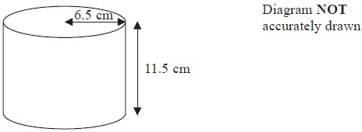

The large tin has a radius of 6.5 cm and a height of 11.5 cm.

A pet food company wants to make a new size of tin.

The new tin will have a radius of 5.8 cm.

It will have the same volume as the large tin.

Calculate the height of the new tin.

Give your answer correct to one decimal place.

........................................................... cm  
**(Total for Question is 3 marks)**

**8.** Ella is designing a glass in the shape of a cylinder.

The glass must hold a minimum of ½ litre of liquid.

The glass must have a diameter of 8 cm.

Calculate the minimum height of the glass.

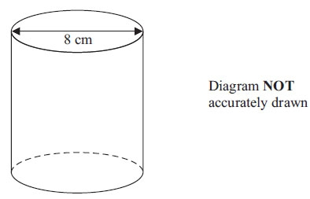

........................................................... cm  
 **(Total for Question is 5 marks)**

**9.** Here is a vase in the shape of a cylinder.

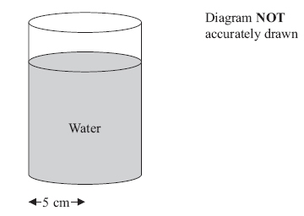

  The vase has a radius of 5 cm.

There are 1000 cm3 of water in the vase.

Work out the depth of the water in the vase.  
 Give your answer correct to 1 decimal place.

........................................................... cm  
 **(Total for Question is 3 marks)**

**10.** The diagram shows a prism.

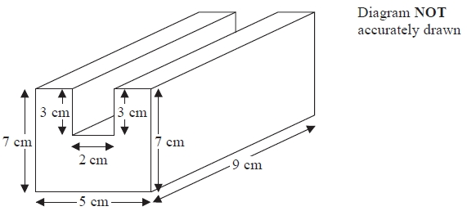

All the corners are right angles.

Work out the volume of the prism.

...........................................................

**(Total for question = 4 marks)**

**11.** The diagram represents a shed.

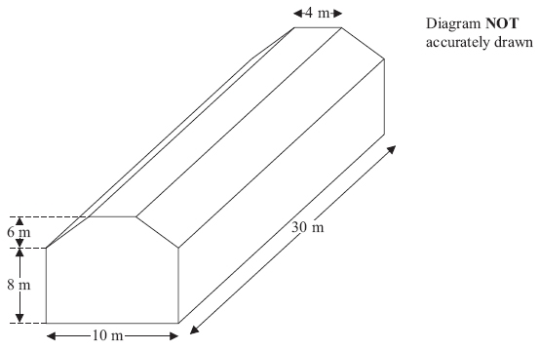

The shed is in the shape of a prism.  
The cross section of the prism is a hexagon.   
The hexagon has one line of symmetry.  
The walls of the shed are vertical.

Calculate the volume of the shed.

........................................................... m3

**(Total for Question is 4 marks)**

**12.** The diagram shows an L-shaped prism.

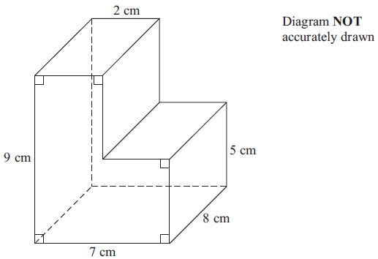

Calculate the volume of the prism.

........................................................... cm3

**(Total for Question is 3 marks)**

**13.** Here is the cross section of a steel girder.

The cross section has two lines of symmetry.

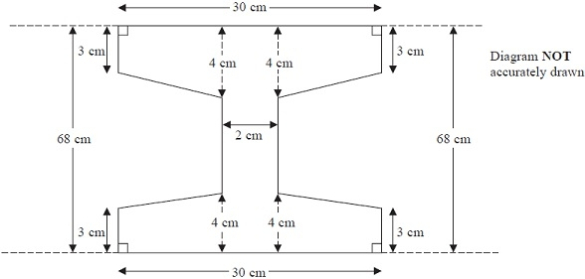

The girder is a prism.

The length of the girder is 200 cm.

Work out the volume of the girder.

........................................................... cm3

**(Total for Question is 5 marks)**

**Volume and Surface Area of Cones and Spheres**

**Things to remember:**

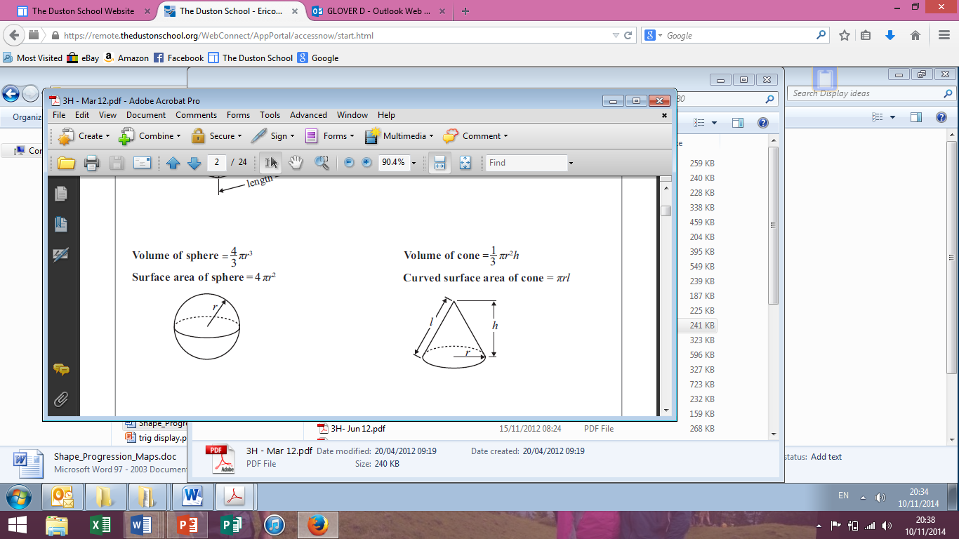

**1.** The diagram shows a storage tank.

Diagram **NOT** accurately drawn

The storage tank consists of a hemisphere on top of a cylinder.

The height of the cylinder is 30 metres.  
The radius of the cylinder is 3 metres.  
The radius of the hemisphere is 3 metres.

(a) Calculate the total volume of the storage tank.  
Give your answer correct to 3 significant figures.

........................................................... m³

**(3)**

A sphere has a volume of 500 m³.

(b) Calculate the radius of the sphere.  
Give your answer correct to 3 significant figures.

........................................................... m

**(3)**

**(Total 6 marks)**

**2.** A clay bowl is in the shape of a hollow hemisphere.

Diagram **NOT** accurately drawn

The external radius of the bowl is 8.2 cm.  
The internal radius of the bowl is 7.7 cm.  
Both measurements are correct to the nearest 0.1 cm.

The upper bound for the volume of clay is *kπ* cm3.  
Find the exact value of *k*.

*k* = ...........................................................

**(Total 4 marks)**

**3.** A rectangular container is 12 cm long, 11 cm wide and 10 cm high.  
The container is filled with water to a depth of 8 cm.

A metal sphere of radius 3.5 cm is placed in the water.  
It sinks to the bottom.

Calculate the rise in the water level.  
Give your answer correct to 3 significant figures.

........................................................... cm

**(Total 4 marks)**

**Volume Involving Algebra**

**Things to remember:**

* Apply what you already know, then simplify the expression or equation.
* You may also need to solve an equation.

**Questions:**

**1.**

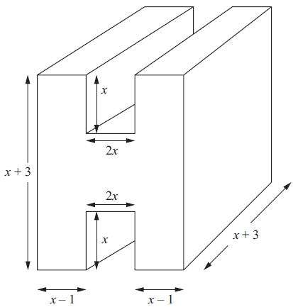Diagram NOT accurately drawn

The diagram shows a prism.  
All measurements are in cm.  
All corners are right angles.  
The volume of the prism is *V* cm3.

Find a formula for *V*.

*V* = ...........................................................

**(Total for Question is 4 marks)**

**2.** The diagram shows a prism.

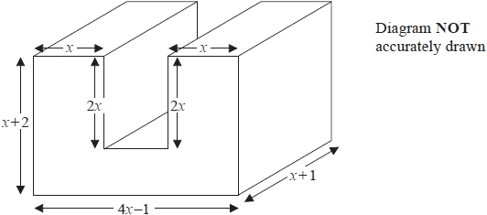

All measurements are in centimetres.   
All corners are right angles.

Find an expression, in terms of *x*, for the volume, in cm3, of the prism.   
You must show your working.   
Give your answer in its simplest form.

...........................................................

**(Total for question = 4 marks)**

**3.** A solid is made by putting a hemisphere on top of a cone.

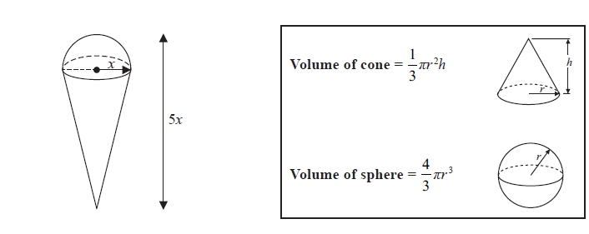

The total height of the solid is 5*x*  
The radius of the base of the cone is *x*  
The radius of the hemisphere is *x*

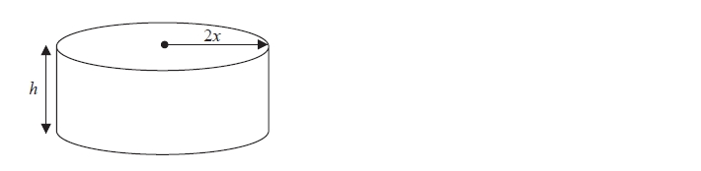

A cylinder has the same volume as the solid.   
The cylinder has radius 2*x* and height *h*  
All measurements are in centimetres.

Find a formula for *h* in terms of *x*  
Give your answer in its simplest form.

...........................................................

**(Total for question = 5 marks)**