Own Question – Authors: ______________________  $f(x)=$ _______________  Graph of $f(x)$:  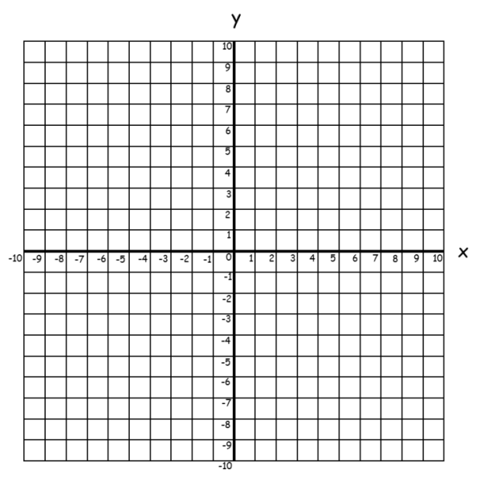  Question:  (Total ____ marks) |   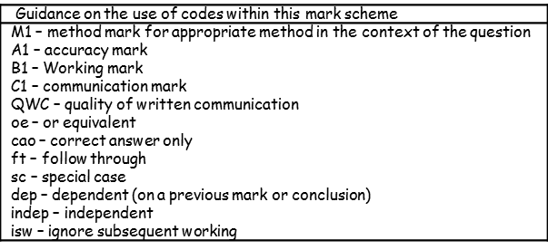  Markscheme

