**Volume and Surface Area (H)**

Pre-Intervention Assessment

Name: _______________________________

Class: _______________________________

Date: _______________________________

|  |  |  |
| --- | --- | --- |
| **Question** | **Objective** | **RAG** |
| 1 | Calculate volume and surface area of prisms, including cylinders |  |
| 2 | Calculate volume and surface area of cones and spheres |  |
| 3 | Solve problems involving volume and algebra |  |

**1.** Here is a solid prism.

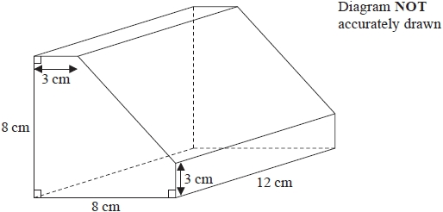

Work out the volume of the prism.   
You must show all your working.

**2.** Diagram **NOT** accurately drawn

The radius of the base of a cone is 5.7 cm.  
Its slant height is 12.6 cm.

Calculate the volume of the cone.  
Give your answer correct to 3 significant figures.

........................................................... cm³

**3**. Here is a cuboid.



All measurements are in centimetres.   
*x* is an integer.   
The total volume of the cuboid is less than 900 cm3

Show that *x* 5.

[Glue here]